Plant GST Rabbit Polyclonal Antibody

CATALOG NUMBER: C1901

QUANTITY: 50µL
DESCRIPTION: The soluble glutathione transferases (GSTs) are encoded by a large and diverse gene family in plants. GSTs are predominantly expressed in the cytosol, where their GSH-dependent catalytic functions include the conjugation and resulting detoxification of herbicides, the reduction of organic hydroperoxides formed during oxidative stress and the isomerization of maleylacetoacetate to fumarylacetoacetate, a key step in the catabolism of tyrosine.
SPECIFICITY: Nicotiana tabacum
ISOTYPE: IgG
MOLECULAR WEIGHT: ~24KDa
TESTED APPLICATIONS: Western Blot

APPLICATIONS: WB: 1:3,000-1:10,000

*NOTE: Optimal working dilutions must be determined by the end user
STORAGE/HANDING: PBS, pH 7.4, containing 0.02% sodium azide as Preservative and 50% Glycerol. Store at -20°C. Do not aliquot the antibody.

Western Blot
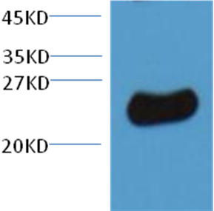
10ug total Nicotiana tabacum lysate + primary antibody dilute at 1:3000

For research use only; not for use as a diagnostic.
Important Note: During shipment, small volumes of product will occasionally become entrapped in the seal of the product vial. For products with volumes of 200 µL or less, we recommend gently dislodge any liquid in the container,‘s cap.

