Myosin Heavy Chain Mouse Monoclonal Antibody (11C2)

CATALOG NUMBER: C1359

QUANTITY: 50µL
DESCRIPTION: Muscle myosin is a hexameric protein that consists of 2 heavy chain subunits (MHC), 2 alkali light chain subunits (MLC) and 2 regulatory light chain subunits (MLC-2). Cardiac MHC exists as two isoforms in humans, alpha-cardiac MHC and beta-cardiac MHC. These two isoforms are expressed in different amounts in the human heart. During normal physiology, beta-cardiac MHC is the predominant form, with the alpha-isoform contributing around only 7% of the total MHC. Mutations of the MHC genes are associated with several different dilated and hypertrophic cardiomyopathies.
SPECIFICITY: Human, Mouse, Rabbit, Fruit Fly, Nematode

ISOTYPE: IgG1

MOLECULAR WEIGHT: ~220KD

APPLICATIONS: IF: 1:100 IHC: 1:200

*NOTE: Optimal working dilutions must be determined by the end user
STORAGE/HANDING: PBS, pH 7.4, containing 0.02% sodium azide as Preservative and 50% Glycerol. Store at -20°C. Do not aliquot the antibody.

Immunofluorescence

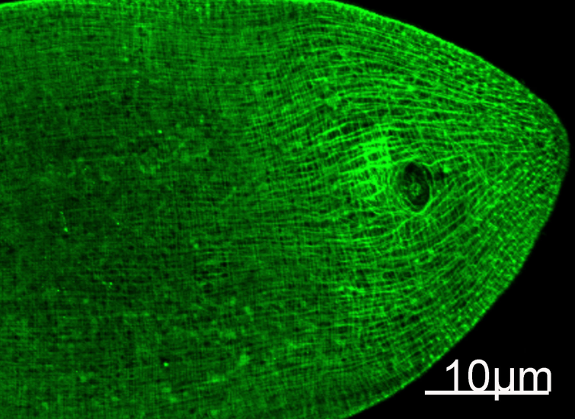
Immunofluorescence Staining of nematode tissue with MYH mouse mAb(11C2) diluted at 1:100. (Provide by Tsinghua University)

Immunochemistry

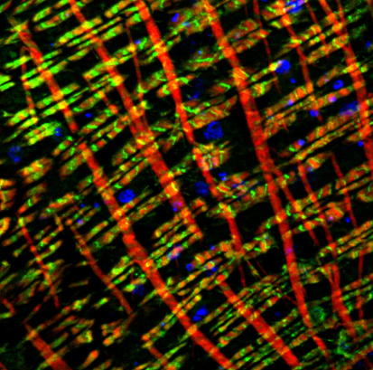
Immunofluorescence double Staining of fruit fly tissue with MYH mouse mAb(11C2)(Green) and F-actin mouse mAb(red) (Provide by NIBS).

For research use only; not for use as a diagnostic.

Important Note: During shipment, small volumes of product will occasionally become entrapped in the seal of the product vial. For products with volumes of 200 µL or less, we recommend gently dislodge any liquid in the container,‘s cap.

