NFκB p65 Mouse Monoclonal Antibody (14H2)

CATALOG NUMBER: C1354

QUANTITY: 50µL
DESCRIPTION: NFkB p65 is ubiquitinated leading to its proteosomal degradation, which is required for termination of the NFkB response. Phosphorylation of NFkB p65 on S536 stimulates acetylation of K310 by CBP, enhancing transcriptional activity. NFkB p65 is also acetylated at K122, enhancing DNA binding and impairing the interaction with NFKBIA. The protein is deacetylated by HDAC3. Invasion of a host by a pathogen is frequently associated with the activation of NF-kB, which coordinates various aspects of immune function required for resistance to infection.
SPECIFICITY: Human, Mouse, Rabbit

ISOTYPE: IgG1

MOLECULAR WEIGHT: ~65KD

APPLICATIONS: WB: 1:1000-1:3000 IHC: 1:200

*NOTE: Optimal working dilutions must be determined by the end user
STORAGE/HANDING: PBS, pH 7.4, containing 0.02% sodium azide as Preservative and 50% Glycerol. Store at -20°C. Do not aliquot the antibody.

Immunochemistry
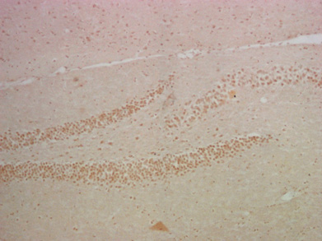
IHC staining of mouse hippocampus tissue with NFκB p65 mouse mAb(14H2) diluted at 1:200.

For research use only; not for use as a diagnostic.
Important Note: During shipment, small volumes of product will occasionally become entrapped in the seal of the product vial. For products with volumes of 200 µL or less, we recommend gently dislodge any liquid in the container,‘s cap.

