NSE Mouse Monoclonal Antibody (13E2)

CATALOG NUMBER: C1367

QUANTITY: 50µL
DESCRIPTION: Enolase is a glycolytic enzyme catalyzing the reaction pathway between 2 phospho glycerate and phosphoenol pyruvate. In mammals, enolase molecules are dimers composed of three distinct subunits (alpha, beta and gamma). The alpha subunit is expressed in most tissues and the beta subunit only in muscle. The gamma subunit is expressed primarily in neurons, in normal and in neoplastic neuroendocrine cells. NSE (neuron specific enolase) is found in elevated concentrations in plasma in certain neoplasias. These include pediatric neuroblastoma and small cell lung cancer. Coexpression of NSE and chromogranin A is common in neuroendocrine neoplasms.
SPECIFICITY: Human，Mouse, Rabbit

ISOTYPE: IgG1

MOLECULAR WEIGHT: ~47KD

APPLICATIONS: WB: 1:2,000 IHC: 1:200

*NOTE: Optimal working dilutions must be determined by the end user
STORAGE/HANDING: PBS, pH 7.4, containing 0.02% sodium azide as Preservative and 50% Glycerol. Store at -20°C. Do not aliquot the antibody.

Immunochemistry
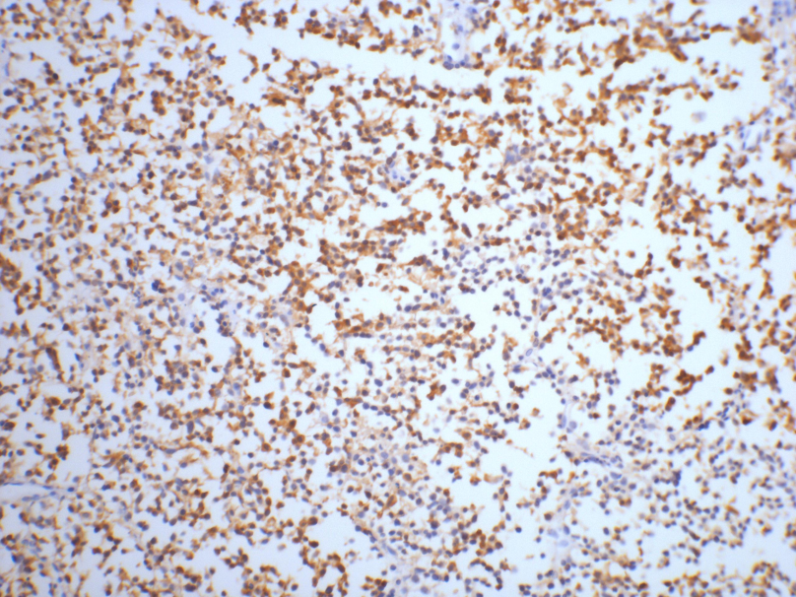
IHC staining of Human small cell carcinoma of lung tissue with NSEmouse mAb(13E2) diluted at 1:200.

For research use only; not for use as a diagnostic.
Important Note: During shipment, small volumes of product will occasionally become entrapped in the seal of the product vial. For products with volumes of 200 µL or less, we recommend gently dislodge any liquid in the container,‘s cap.

